General Information
Topic | Requirement Gathering Meeting
Date | 11/02/2025
Time | From – 05:30 PM IST To 07:15 PM IST
Conducted by | Bala Madiraju & Vijeesh MP (Client Team)
Participants | SPEC India  Present:  Parth Jotangiya, Sandip Sadhu, Jayendra Makwana  Absent: Mitesh Modi | Customer  Present:  Bala Madiraju  Absent: Vijeesh MP
Agenda: Discussion regarding project requirements

Key finding and decision
Keyword/Topic | Discussions/Decisions/Information
Confirmation on the shared MoM & shared Figma Design | - Bala will review all MoM files and provide his confirmation or feedback by today or tomorrow.  - Bala will review the shared Figma design for the License Application and provide his confirmation or feedback by today or tomorrow.
Application Details | - cPanel & Source Code Access: Bala and Vijeesh will share cPanel access and the source code for both applications with the SPEC Team for internal review and future reference. This will be done after completing the handover session with the old vendor, tentatively on Wednesday or Thursday.  - Updated Figma Design: The SPEC Team shared the updated Figma design on Monday, 10th February 2025, at 7:53 PM (IST). This version includes all previously suggested changes mentioned in the email sent on 10th February 2025, at 11:42 AM (IST) to Bala and his team.  - Font Update for License Application:  - Only one change is pending, which is related to the “Dejavu Sans” font in the updated Figma file.  - Today, on 12th February 2025, Bala shared a new font named "Open Sans".  - The SPEC Team will now update this font in all relevant places within the License Application and share the updated Figma design with Bala and his team.  - The updated design is expected to be shared by Friday, 14th February 2025.  - Figma Flow Confirmation:  - The SPEC Team is waiting for Bala's confirmation on the latest shared Figma flow for the License Application.  - This confirmation is essential to finalize the application requirements, proceed with preparing the SRS, and initiate development activities.  - MoM Review & Approval:  - The SPEC Team has requested Bala to review all Minutes of Meeting (MoM) shared so far and provide confirmation/approval to proceed with the next steps.  - Bala will review and get back to SPEC Team by today or tomorrow EOD.  - Key Discussion & Conclusion from Today's Meeting:  - License Creation & Validation Flow:  - The SPEC Team demonstrated the entire License Creation & Validation flow and prepared the License File.  - Bala approved the flow and suggested encrypting the highlighted plain text in the license file to enhance security.  - The file extension will remain ".lic".  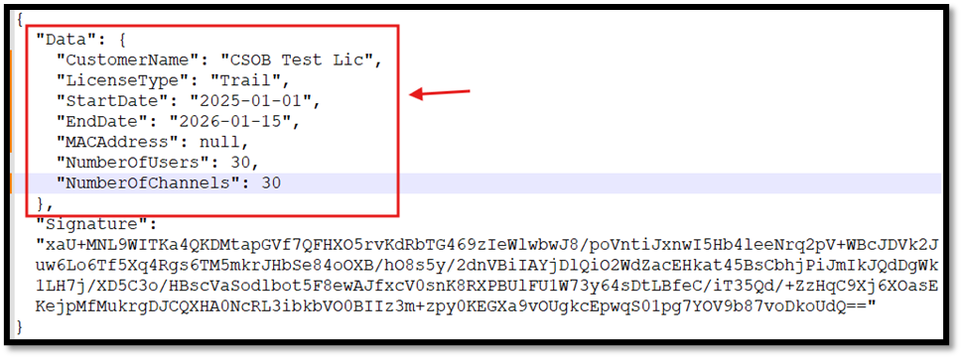  - The license file will be configured for a specific customer with a specific MAC Address and Site Name, ensuring it cannot be accessed by another customer or machine.  - The file content will be encrypted, preventing unauthorized access and enhancing security.  - The License Application will provide an option for authenticated users to download the license file directly from the application.  - The BI Dashboard Web Application will include an option to browse and upload the license file from the local machine for validation and authentication for the specific customer.  - Camera Management:  - This feature will allow configuring devices with two options:  - Camera  - AI Box (In this option, the user must enter the Channel Number, and the system will call an API to fetch details of associated cameras & display further information on the screen. Clarity on API integration is yet pending)  - Associated API Names:  - Bala will schedule a meeting with the respective technical team to discuss all API-related queries and clarifications needed for project integration.  - Map Plan Management:  - Bala will share the detailed list of features to be implemented on the Map Plan.  - The SPEC Team will conduct R&D and finalize requirements with Bala before proceeding with development.  - Floor Plan Management:  - A 10 MB size restriction will be applied for file uploads.  - The system will support file formats: .dwg, .pdf, .jpg, .png, .jpeg, .svg. SPEC Team will check the feasibilities of above mentioned file format & get back to Bala in case of any issues with the implementation for the same.  - Users will be able to Zoom-In and Zoom-Out on the uploaded floor plan image.  - The SPEC Team will replicate the existing BI Dashboard Floor Plan features, incorporating the above enhancements.  - Zone Management:  - If the Max Occupancy is exceeded,  - An email notification will be sent to the admin user based on his/her configured settings.  - The admin user will receive an alert within the BI Dashboard Web Application immediately when an alert is triggered due to exceeding the max occupancy.  - The following fields will be included when creating a zone on the floor plan:  - Name of the Zone*: A unique identifier for the zone.  - Max Occupancy*: The maximum number of people or vehicles allowed in the zone.  - People Occupancy: The max number of people allowed.  - Vehicle Occupancy: The max number of vehicles allowed.  - Reset At*: A time value defining when occupancy counts reset.  - Add cameras on zones:  - The system will display only online cameras that are pending configuration.  - The camera list will include data filtration options for the following columns:  - Camera Name / Description  - IP Address  - Users will be able to configure an unlimited number of cameras within a specific zone (no restriction).  - Each configured camera will be exclusively linked to a specific zone.  - Camera rotation:  - The SPEC Team demonstrated the camera rotation implementation.  - Bala reviewed and approved the implementation, confirming to proceed further.  - Regarding APIs discussion: Bala has scheduled a meeting with Sujith Raman to discuss API-related queries on 14 February 2025 11.30 AM-12.00 PM (IST) & 10:00 AM-10:30 AM (Dubai time).
Next Regular Meetings | - Bala will be occupied for the next two days, so there will be no meeting on 12th and 13th February 2025.
Sample File for License | - Bala / Vijeesh will share sample file for license for SPEC’s reference after that SPEC Team reviews the file & suggest in case of any good alternatives.
Device setup from SPEC’s end | - Vijeesh is on leave this week and will configure the required applications on the dedicated machine on Monday, 17th February 2025.
Physical Camera Devices | - Hanwha's team will send three different types of physical camera devices to test the data and functionality at the SPEC premises, and they’ve proposed to set up the camera at the SPEC premise for the testing of the data and functionalities. Regarding that, the SPEC team will check with SPEC management and confirm to proceed with the same.

Follow up items
Description/Action Items | Responsibility | Due Date | Status
Updated PO Details | Hanwha Team | 06/02/2025 | Completed
URL & Credentials for Licensor Application | Hanwha Team | 04/02/2025 | Completed
Details of cPanel & Source Code of both the application for future reference | Hanwha Team | 04/02/2025 | Pending
Meeting with respective technical person who will assist SPEC Team in API usage & its flow.  - Scheduled on this Friday | Hanwha Team | 10/02/2025 | Completed
Physical Camera Devices setup at SPEC’s premises  - Bala will arrange 3 physical camera & in the meantime, SPEC Team will confirm it with their management team. | Hanwha & SPEC Team | 10/02/2025 | Pending
Device setup from SPEC’s end (Machine / PC)  - Vijeesh will configure it on Monday, 17th February 2025 | Hanwha Team | 14/02/2025 | Pending
Sample file for License | Hanwha Team | 06/02/2025 | Pending
List of Functionalities to be implemented in the Map Plan | Hanwha Team | 12/02/2025 | Pending

